PLOT

Kaguya is a beautiful young woman coveted by five nobles. To try to avoid marrying a stranger she doesn't love, she sends her suitors on seemingly impossible tasks. But she will have to face her fate and punishment for her choices.

Description  
Episode 1

Based on a classic Japanese folktale, it tells the story of a magical girl found inside a bamboo stalk who grows into a captivating young woman. The film's unique hand-drawn animation style, inspired by traditional Japanese art, creates a visually stunning and deeply emotional experience.

Episode 2

The film follows Princess Kaguya, discovered as a tiny girl inside bamboo, as she grows and faces the complexities of human life. The delicate, sumi-e inspired animation enhances this meditative and moving cinematic journey.

Episode 3

Found as a baby inside a bamboo stalk, Princess Kaguya matures into a beautiful woman, confronting noble suitors and royal expectations. The film's exquisite visuals and evocative storytelling explore themes of love, loss, and the quest for happiness, making it a timeless reflection on human existence.

Search for trailer and clips related

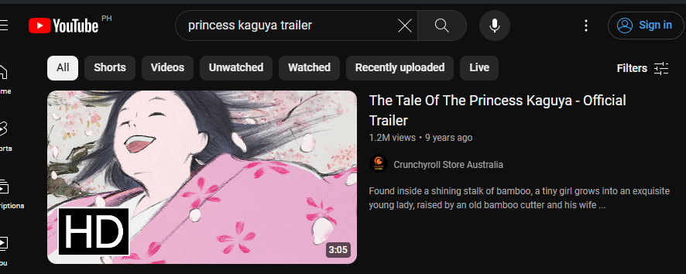

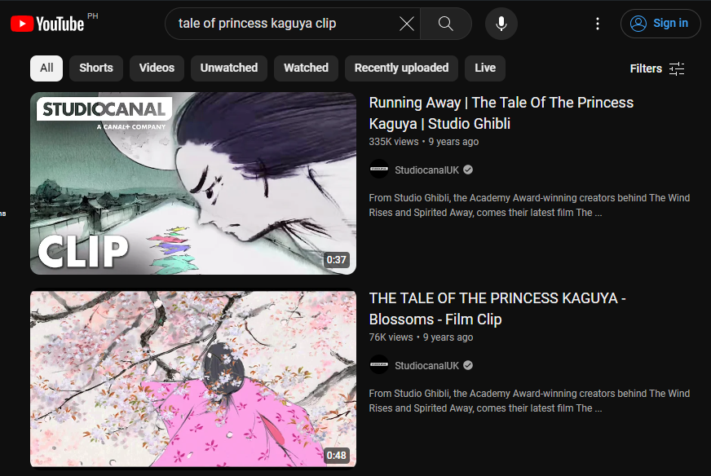

Chatgpt for description



